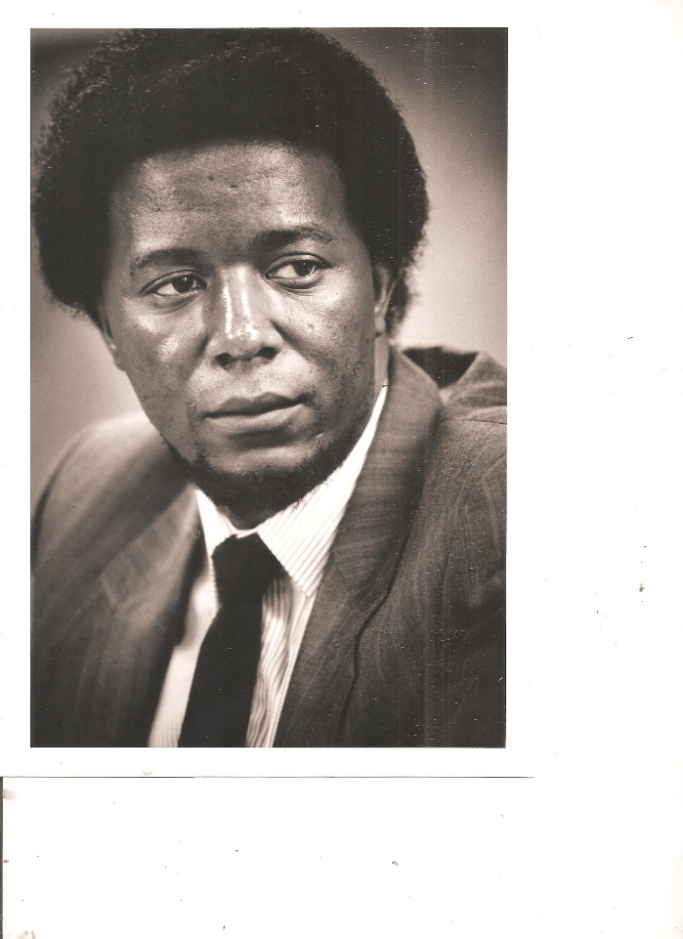

Prof. Dr. Bongani Khumalo

1952 - 2020

uBongani Khumalo

insizwa [kaMkhulunyelwa](https://www.benkhumalo-seegelken.de/persoenlich-daheim/2651-untabayezulu-1918-1990/), umfana ka[Ndindi](https://www.benkhumalo-seegelken.de/persoenlich-daheim/2608-kwethu/),

uMQulusi , uMzansi

uBongani Khumalo

**ngumuntu**

olungile, onomusa - onomoya omuhle;

oqotho, onesimilo,

onogazi;

ohloniphayo nohlonishwayo

ozithobayo, onemfundiso.

uBongani Khumalo

**ngumuntu**

okhuthele, onekhono, onokuzimisela nonentshisekelo;

ngumakhi nomeluleki

onengqondo, onezikhwepha, onomfutho, onesibindi,

ophembayo, ovuthelelayo, ofukulayo,

ovuselelayo.

uBongani Khumalo

**ngumuntu**

oyigagu, oyinono, ocophelelayo,

ocwaningisayo, ohlolisisayo,

igcokama;

ikholwa eliyisibonelo - isethenjwa.

uBongani Khumalo

**ngumuntu**

oneso, onesandla, onenhliziyo ehle;

obonelelayo, obekezelelayo,

onesihe, onozwelo;

ocebisayo, oxolelayo.

uBongani Khumalo

ngumuntu

ongumhlahlandlela,

obona kude,

**iqhawe - ingqwele!**

[M z i l i k a z i](https://www.benkhumalo-seegelken.de/persoenlich-daheim/2653-izithakazelo-zabakwakhumalo/) !

[eKhaya eJalimane](https://www.benkhumalo-seegelken.de/)

30.12.2020