Bibilia Zuluensis

iViyo leziKhuthali oBanjiswaneni
lokuHumusha nokuBhala kabusha iBhaybheli ngesiZulu

UMHLANGANO WONYAKA

eThekwini, eMhlathuzana: Mariannhill Monastery
10. – 12.09.2010

A M A M I N I T H I

- ABAKHONA

NgoMbongeni Mbatha/eMondlo; noFelix Khwela/kwaMaphumulo; noLungile Khobeni/eMgungundlovana; noMargaret Shabangu/eSiphingo; noSolomuzi Mabuza/ eMgungundlovu; noNjabulo Ndaba/eVlayhede noBheni Khumalo-Seegelken/eJalimane.

- ABANGAPHUMELELANGA

ONkosikazi uSibongile Magwaza noMnumzane uBhekumuzi Hlatshwayo bagciné bengafikanga.

USobaba uMbhishobhi uDlungwane noFata uMadela kanye nethimba abasebenzelana nalo, ebesizokwethekelelana nabo, sigciné singababonanga.

- UMSEBENZI NGOLWESIHLANU (10.09.2010)

  - Emva kokubingelelana nokwemukelwa endaweni yaseMhlathuzana (eMariannhill) sidla ukudla kwakusihlwa.

  - Sixoxelana ezisematheni, sibonisana ngendlela esizoqhuba ngayo kule mpelasonto.

  - UMfundisi uDokotela uKhumalo usibikela ukuthi uMphathi wesikole seMfundo yezeNkolo eNyuvesi yakwaZulu-Natali usimemela ukuthi ngonyaka ozayo siwubambele khona umhlangano wethu ukuze sixhumane nabaFundi nabaFundisi kwezeNkolo, sichathekelelane ulwazi kwezokuhunyushwa kweBhaybheli lifakwa esiZulwini. Sivumelana ngokusemukela isimemo, ngonyaka ozayo sihlanganele khona eMgungundlovu ngempelasonto yesibili kuSebthemba (09.-11.09.2011); bese kuthi ngakusasa ngoMsombuluko (12.09.2011) sihlangane nabaFundi nabaFundisi njengokwesifiso esisamukele.

  - Siyawuphetha umsebenzi wosuku.

- UMSEBENZI NGOMGQIBELO (11.09.2010)

  - Emva kokudla kwasekuseni semukela abaqalayo ukuhlanganyela nathi, sibachazela ngenhloso yoBanjiswano lweViyo lethu, sibaxoxela kafuphi ngezindima esesedlulé kuzo, sibakhuthaza ukuthi bangene, siqhubeke.

  - Sicubungula iHubo lekhulu namashumi amabili nanye (121), silithatha emsukeni walo encwadini yeNkolo yobuJuda, ibiblia hebraica, (zibonele ekhasini eliphelekezela la maminithi iHubo 121 ngesiHebheru) sinambithisisa ukubekwa kwemisho ngolwimi lwesiHebheru, nalowo nalowo uthatha ithuba lokuzifundela yedwana, ahumushe uhlamvu ngohlamvu, enze imisho ngesiZulu, ahlole kwamanye amaBhaybheli esiZulu (elowe-1893 nelowe-1959) ukuthi khona le ndima ibekwe kanjani, awuphethe umzamo wakhe, bese sihlangana futhi, sikhombisana imizamo yethu ngokwehlukana kwayo, sichazelana lapho kunemibuzo khona, sisizwa nguMfundisi uKhumalo nezincwadi zoLwazi ngezoKholo nangezokuHumusha.

  - Engxoxweni elandela umshikashika wokuhumusha sikhumbuzana ngoLwazi ekuHumusheni iBhaybheli okufanele singalulibali - ikakhulukazi: >> njengenhlwathi nenyamazane ; BHALA NJENGOBA UKHULUMA (" Bhanjekhu "); sifundisana ukufunda isiHebheru .

  - Sibukeza izindima ezimbalwa esesedlule kuzo ukuze sicathulisane nabasaqalayo: ithestamente elidala lavelaphi? ; ithestamente elidala lisalifundelwani? ; umlando wokwenanwa kwezincwadi zethestamente elidala (ThD) .

  - Sithatha ithuba lokuphuma, sibuke ubuhle bomuzi waseMarianhill, sathola nosiphelekezelayo, esikhombisa ingxenye yezakhiwo, esixoxela ngomlando wendawo.

  - Siyaqhubeka, sifunda iHubo lekhulu namashumi amabili nanye (121) ngesiHebheru bese silihumushela esiZulwini.

  - Siyakhumbuzana: umlando wokwenanwa kwezincwadi zethestamente elidala (ThD)

  - Siyafundisana, siyakhumbuzana: umlando wekwenanwa kwezincwadi zethestamente elisha (ThSh )

  - Siyawuphetha umsebenzi wosuku.

- UMSEBENZI NGESONTO (12.09.2010)

  - Emva kokudla kwasekuseni sihumusha iHubo lekhulu namashumi amabili (120) - nalo silisusela kubiblia hebraica silifaka esiZulwini sanamuhla. UMfundisi uKhumalo usikhuthaza ukuthi sizinike ithuba lokukwazi ukusichaza ngasinye ngasinye isinyathelo esisithathayo emzamweni wokuhumusha izinhlamvu nemisho sizifaka esiZulwini, sichaze ngendlela ezwakalayo nelandeleka kalula – okuyindla yokubukezisisa lonke uLwazi kwezokuHumusha nakwezeNkolo esiluthola njengoba sisebenza-nje.

  - Sikhumbuzana ngokubaluleka kokuthi sibe okungenani yishumi nambili (12) eViyweni lethu ukuze kusebenzeke ngemfanelo, nemibono namakhono kwesekane; siqakamelele futhi ukuthi isibalo sabesilisa nesabesimame, sabadala (30+) nabancane (-30) silingane, sibambisane, sidedelane ngokwehlukana kwamakhono ethu nokwezindlela esisikhuluma ngaso isiZulu ngezigodi ngezigodi esiqhamuka kuzo.

  - Sivumelana ngokuthi sizoqala manje-nje ngoOkthoba ukufunda, sihumushe iNcwadi yokuQala kaSamuweli (Sam I). Umsuka wayo ngesiHebheru uzosithumelela uMfundisi uKhumalo ngokushesha, siqhubeke yilowo nalowo ngokwakhe yedwana elekelelana nelakhe iviywana uma ethanda, njengoba besenza kule mpelasonto.

  - UNkosikazi uLungile Khobeni uqoqa amakheli abakhona ukuze kuxhumaneke lula. (Nanto emhlane wala maminithi).

  - Ishashalazi lethu lasemoyeni kusazoqhubeka kuyileli http://www.benkhumalo-seegelken.de/ibhaybheli.html naleli http://www.benkhumalo-seegelken.de/texte-ibhaybheli.html

  - Sikhumbuzana ukuthi ngamunye ngamunye kufanele afake esikhwanyaneni seViyo amaRandi angamashumi ayisithupha (R60) ngonyaka ukuze sikwazi ukuhlangabezana nezindleko zeposi nokubhalelana. UMnumzana uMbongeni Mbatha simcela ukuthi aqhubeke asiphathele leso sikhwanyana.

  - Siyawuphetha umhlangano.

nguNjabulo N d a b a.

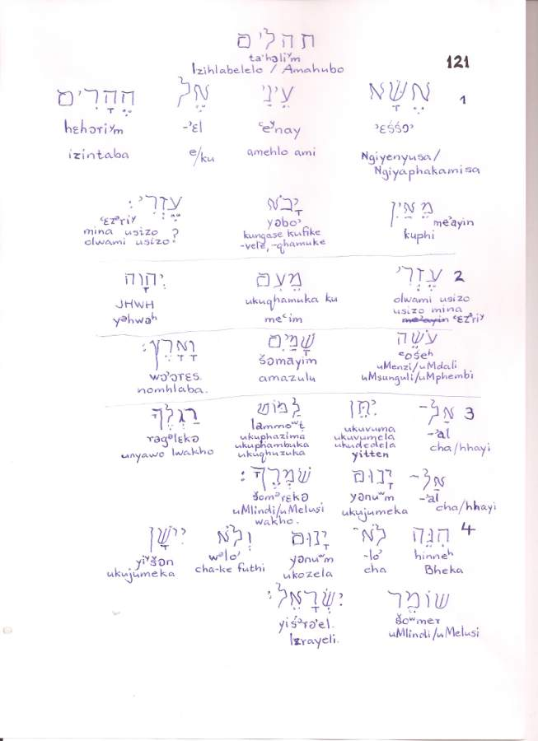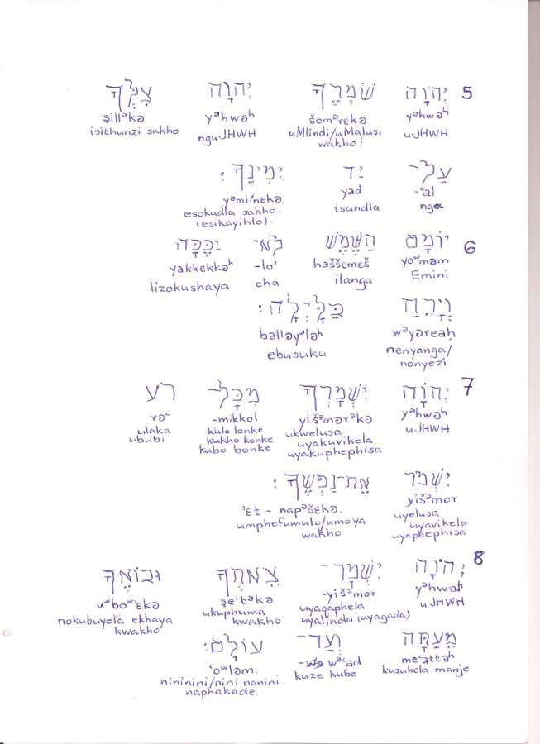

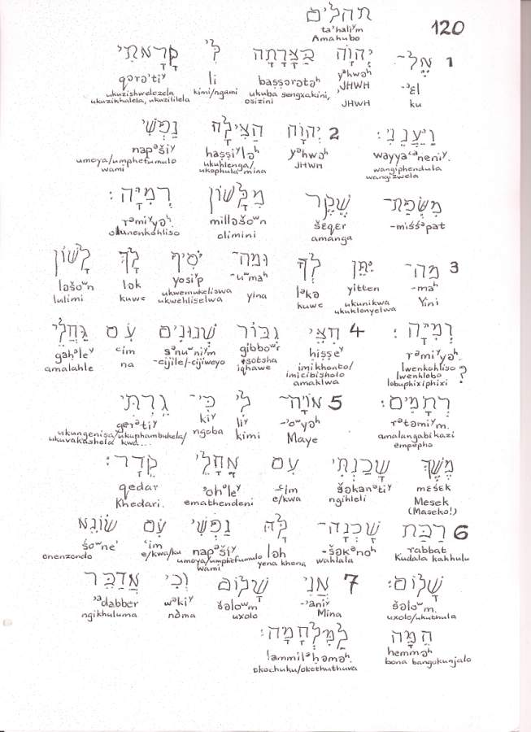

bibilia zuluensis
iViyo leziKhuthali
oBanjiswaneni lokuHumusa nokuBhala kabusha iBhaybheli ngesiZulu

AMAKHELI
Margaret Thoko Shabangu
No. 32 Fiddlewood Drive, Isipingo Hills, 4133
031-9025876 (ekhaya) 031 – 2059941 (emsebenzini) 083-7637476 (umakhal’ekhukhwini)
shabangutm@gmail.com

Solomuzi Mabuza
No. 5 Frans Hugo Circle, Signal Hill, Pietermaritzburg, 3201
033-2605796 (emsebenzini) 033-3443395 (ekhaya) 033-2606294 (ifeksi)
umakhal’ekhukhwini: 082-4208341
mabuzaso@ukzn.ac.za
warona@gmail.com

Njabulo Ndaba
P.O. Box 10039, Vryheid, 3100
umakhal’ekhukhwini: 073-3983692
njabulondaba@yahoo.com

Felix Vusumuzi Khwela
P.O.Box 8, Maphumulo, 4470
P.O. Box 1296, Vryheid, 3100
umakhal’ekhukhwini: 0823674341

Mbongeni A. Mbatha
P.O. Box 81, eMondlo, 3105
034-9331131 (ekhaya); 084-3067999 (umakhal’ekhukhwini)

Bheni Mhlanganisi Khumalo (Dr. Ben Khumalo-Seegelken)
KwaMchanca, Alte Ziegelei 4, D-26197, HUNTLOSEN, eJalimane/Germany
0049-4487-750285 ben.khumalo.seegelken@uni-oldenburg.de

Lungi Khobeni (Stella Cockburn)
P.O. Box 381, Greytown, 3250
033-4450601 ext. 44 (emsebenzini); 033-4133438 (ekhaya); 082-5781356 (umakhal’ekhukhwini)
pro@hmbschool.co.za

